Cloud Computing assignment
- Make a list of all top CRM softwares(cloud and on-premises) and note why Salesforce has an edge over other CRMs
Customer Relationship Management (CRM) software helps organizations manage customer interactions, sales processes, marketing campaigns, and customer service operations. CRM systems have evolved from traditional on-premises solutions to cloud-based platforms that provide scalability, automation, analytics, and Artificial Intelligence (AI). Today, the CRM market is dominated by leading vendors such as Salesforce, Microsoft, Oracle, SAP, HubSpot, and Zoho. Among these, Salesforce is widely recognized as the global CRM leader because of its innovation, ecosystem, flexibility, and customer-centric approach.
Top 10 Cloud CRM Software
Cloud CRM solutions are hosted on the vendor's infrastructure and accessed through the internet. They require minimal hardware investment and offer easier maintenance and scalability.
Rank | Cloud CRM Software | Vendor | Key Features
1 | Salesforce Sales Cloud | Salesforce | Sales automation, AI, analytics, ecosystem
2 | Microsoft Dynamics 365 | Microsoft | CRM + ERP integration, Microsoft ecosystem
3 | HubSpot CRM | HubSpot | User-friendly, marketing automation
4 | Oracle CX Cloud | Oracle | Enterprise customer experience management
5 | SAP Sales Cloud | SAP | Strong integration with SAP ERP
6 | Zoho CRM | Zoho | Affordable and highly customizable
7 | Freshsales | Freshworks | AI-powered sales management
8 | Zendesk Sell | Zendesk | CRM with customer support capabilities
9 | SugarCRM Cloud | SugarCRM | Flexible workflow automation
10 | Creatio CRM | Creatio | Low-code CRM platform
Many industry analysts and market reports consistently rank Salesforce, Microsoft Dynamics 365, Oracle, SAP, HubSpot, and Zoho among the most widely used cloud CRM platforms globally. [appsruntheworld.com], [cxtoday.com]
Top 10 On-Premises CRM Software
On-premises CRM solutions are installed and managed within an organization's own data center, offering greater control over infrastructure and data security.
Rank | On-Premises CRM Software | Vendor | Key Features
1 | Oracle Siebel CRM | Oracle | Deep enterprise functionality
2 | Microsoft Dynamics CRM On-Premises | Microsoft | Enterprise-grade CRM
3 | SAP CRM | SAP | Integrated enterprise processes
4 | SugarCRM Enterprise | SugarCRM | Flexible deployment
5 | Infor CRM | Infor | Manufacturing-focused
6 | Sage CRM | Sage | SMB-focused CRM
7 | GoldMine CRM | GoldMine | Traditional customer management
8 | SuiteCRM | Open Source | Highly customizable
9 | Vtiger CRM | Open Source | Cost-effective CRM
10 | CRMNEXT | CRMNEXT | Banking and financial services focus
Oracle Siebel CRM remains one of the most mature and feature-rich on-premises CRM solutions and continues to be used in highly regulated industries such as banking, telecommunications, healthcare, and government.
Why Salesforce Has an Edge Over Other CRM Platforms
- Market Leadership and Customer Trust
Salesforce is the most widely used CRM platform in the world, and this leadership itself gives it a significant advantage. When businesses choose Salesforce, they are investing in a platform that has already been tested and adopted by organizations across almost every industry. Because of its large customer base, Salesforce benefits from extensive community support, proven implementation practices, and continuous product improvements. This strong market presence creates trust among businesses and makes Salesforce the preferred choice for many organizations. As more companies adopt Salesforce, its dominance continues to grow, strengthening its position in the CRM market. [appsruntheworld.com], [cxtoday.com]
2. Complete Customer 360 Ecosystem
One of Salesforce's biggest strengths is that it goes beyond traditional CRM functions. Through products such as Sales Cloud, Service Cloud, Marketing Cloud, Commerce Cloud, Experience Cloud, and Data Cloud, Salesforce provides a complete view of the customer on a single platform. Instead of using multiple disconnected systems, organizations can manage sales, customer service, marketing campaigns, and customer interactions from one place. This unified approach improves customer experience and gives Salesforce a competitive advantage over vendors that specialize in only one area of customer management. [cxtoday.com]
3. High Flexibility and Customization
Every organization operates differently, and Salesforce understands that a "one-size-fits-all" approach does not work. The platform allows businesses to customize workflows, user interfaces, reports, dashboards, security settings, and even build entirely new applications. Through tools such as Salesforce Flow, Lightning Platform, and Apex programming, organizations can adapt Salesforce to their specific requirements. This flexibility enables Salesforce to support both small businesses and large multinational companies, giving it a broader market reach than many competitors.
4. Powerful Ecosystem Through AppExchange
Salesforce has built one of the largest business software ecosystems through AppExchange. Thousands of ready-made applications and integrations are available for organizations to extend CRM functionality without extensive development work. Whether a business needs accounting software integration, document management, customer support tools, or industry-specific applications, solutions are readily available. This ecosystem reduces implementation time and cost while making Salesforce more attractive than CRM platforms with limited extension options.
5. Leadership in AI and Automation
Salesforce has been one of the most aggressive CRM vendors in adopting Artificial Intelligence. Features such as Einstein AI, predictive analytics, automated lead scoring, intelligent recommendations, and Agentforce AI agents help organizations automate routine tasks and make smarter business decisions. By embedding AI directly into sales, service, and marketing processes, Salesforce helps companies improve productivity and customer engagement. This focus on practical AI applications has helped Salesforce strengthen its market position as businesses increasingly seek intelligent CRM solutions. [cxtoday.com]
6. Strong Integration Capabilities
Modern organizations rely on multiple business applications, including ERP systems, accounting software, cloud platforms, and legacy applications. Salesforce excels at connecting these systems through APIs, pre-built connectors, and MuleSoft integration capabilities. This ability to bring data together from various sources creates a unified customer view and eliminates information silos. Because businesses can easily integrate Salesforce with their existing technology stack, it becomes a more attractive option than many competing CRM solutions.
7. Industry-Specific Solutions
Salesforce has expanded beyond generic CRM by offering solutions tailored to specific industries such as banking, healthcare, insurance, retail, manufacturing, telecommunications, government, and non-profit organizations. These industry clouds contain pre-built workflows, compliance frameworks, and best practices. As a result, organizations can deploy Salesforce more quickly and achieve faster business value. This industry-focused approach allows Salesforce to address specialized business needs better than many general-purpose CRM platforms. [cxtoday.com]
8. Massive Partner and Developer Network
Another reason for Salesforce's success is its extensive global community. Thousands of certified administrators, developers, architects, and consultants work within the Salesforce ecosystem. Major consulting firms such as Accenture, Deloitte, PwC, Infosys, TCS, and Wipro provide Salesforce implementation and support services. This large talent pool reduces project risk for organizations because finding skilled resources is easier compared to many competing CRM platforms. The strong community also drives innovation and knowledge sharing, further reinforcing Salesforce's market leadership.
9. First-Mover Advantage in Cloud CRM
Salesforce was among the first companies to popularize the cloud-based CRM model. While many traditional vendors focused on on-premises solutions, Salesforce promoted Software-as-a-Service (SaaS), making CRM easier to deploy and maintain. This early move allowed Salesforce to build a massive customer base, establish strong brand recognition, and gain years of experience in cloud technology before many competitors entered the market.
10. Scalability and Long-Term Growth
One of the key reasons organizations choose Salesforce is its ability to scale as businesses grow. A company can start with basic CRM functions and later expand into customer service, marketing automation, analytics, AI, and advanced integrations without changing platforms. This scalability protects the organization's investment and makes Salesforce a long-term strategic solution rather than just a CRM application.
- Sign up a new Salesforce developer instance using https://developer.salesforce.com/signup
  - Login into the instance
  - Create a Lead by your name and email address
  - Convert a lead into Account, Contact and Opportunity

Lead Created
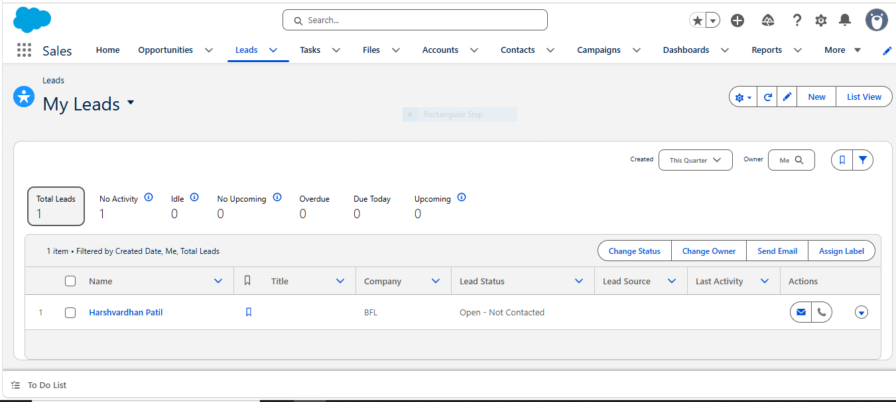

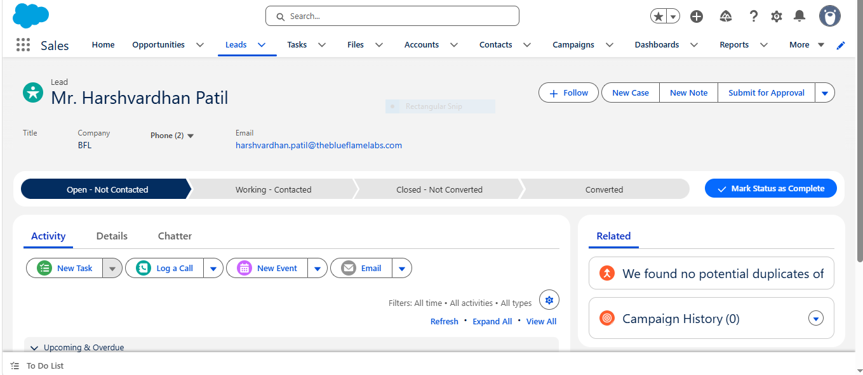

Successfully Converted the lead
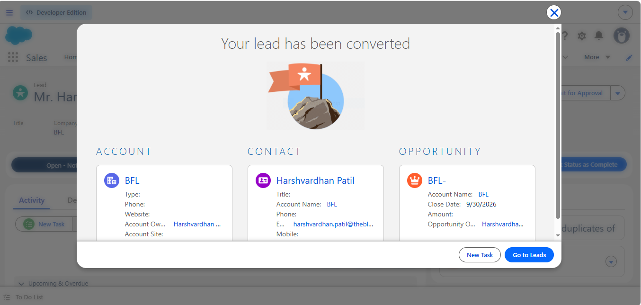
- Sign up into trailhead
Completed the Salesforce CRM course on Trailhead
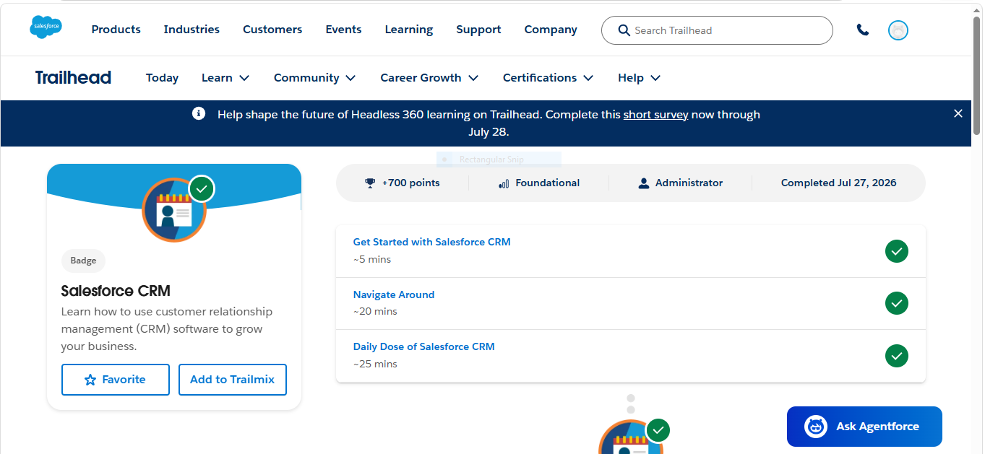
Completed Cloud Computing and CRM fundamentals course on Keka
